Firstly to set up connection with sql

mysql -u retail_user -h g02.itversity.com -p;

passoword: itversity

MariaDB [(none)]> show databases;

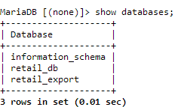

MariaDB [(none)]> use retail_db;

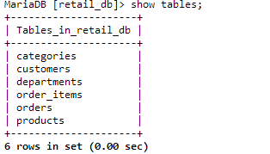

Import all table from Mysql retailer_db to hdfs /user/itv003722/dataco

sqoop import-all-tables --connect jdbc:mysql://g02.itversity.com/retail_db --username retail_user --password itversity --warehouse-dir /user/itv003722/dataco

